Dear Team,
We are happy to announce a new function available in your Outlook:
The “PHISH ALERT Button”, which will be available at the top of your outlook ribbon.
You can also right click on any email and use the “Report” button to “Report Phishing”
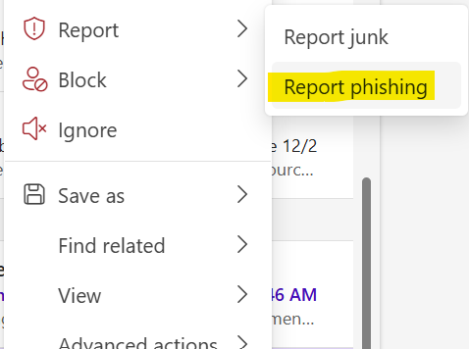
This add-in will allow you to report suspicious emails easily and instantly to the Information Security Team for analysis.

What is The Phishing Reporter add-in?
The Phishing Reporter add-in is an Outlook plugin which will enable you to report suspicious emails to your organization. It will also provide the opportunity to timely identify email-borne cyber-threats and take certain actions at the system level before any damage occurs.
What will the add-on bring?
• You can report attacks with a click.
• Timely notifications of "Phishing" attacks will help the information security team to be more proactive and will reinforce our company’s cybersecurity posture.
• The add-in will help you to be more aware of cyber risks.
If you have any questions, please reach out to support@ninjio.com.

