Dear Team,
We are happy to announce a new function available in Google Gmail:

The “PHISH ALERT Button” is found on the right sidebar with the other quick access Workspace apps.

This add-in will allow you to report suspicious emails easily and instantly to the Information Security Team for analysis. Please read the instructions below to understand how to use this add-on.
What is The Phishing Reporter add-in?
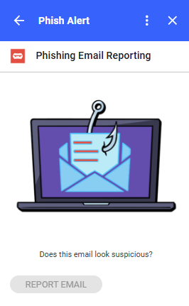
The Phishing Reporter add-in is a Gmail add-in application which will enable you to report suspicious emails to your organization.
It will also provide the opportunity to timely identify email-borne cyber-threats and take certain actions at the system level before any damage occurs.
What will the add-on bring?
• You can report attacks and possible email threats with a simple click.
To report an email you have open, click on the Phish Alert icon and use the “REPORT EMAIL” button that is displayed.
• Timely notifications of Phishing attacks will help the information security team to be more proactive and will reinforce our company’s cybersecurity posture.
• The add-in will help you to be more aware of cyber risks.
If you have any questions, please reach out to support@ninjio.com.

