Dear Team:

In an effort to keep our organization and people secure from cyber-attacks, we’ve partnered with an organization called NINJIO.

As part of this partnership, NINJIO will be releasing animated story-based episodes that are designed to educate us about cyber-security.

We strongly feel that these brief episodes will teach and reinforce security topics and will ultimately lead you, and our organization, to a higher level of awareness and security. These entertaining and educational episodes will benefit you both at work and at home, as the lessons apply to you in your professional and personal lives.

What to expect next:
You have already been registered with NINJIO. The first notification that you will see from NINJIO will be your enrollment into the first episode.
This email will come from: no-reply@goninjio.com

We will receive four weekly episodes to start. Afterwards, we will receive one episode per month.

  - Sample Enrollment Email
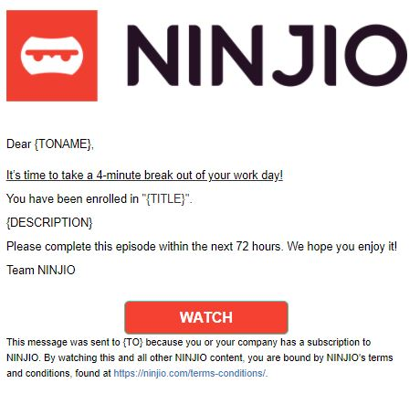

  - To watch your episode, click the “Watch” button. It is important to note, these emails should NOT be forwarded to colleagues. If you need your enrollment email re-issued, please contact support@ninjio.com

  - Episodes will be about 4 minutes long, with a brief true/false quiz at the end of the course.

  - If you received a passing grade on the quiz, you would receive an email with a Certificate of Completion. If the course displays the correct answers, you have failed the quiz. Please rewatch the video, to retry the quiz.

  - You will receive weekly email reminder emails if the episode quiz has not been completed or passed.

  - The recommended browsers for viewing these trainings are Chrome and Edge.

  - Be sure to use the “Exit” button to properly complete the course.
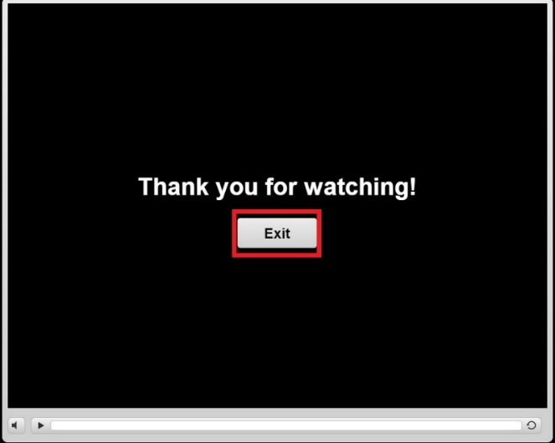

If you would like to learn more about NINJIO, we encourage you to visit www.ninjio.com

Thank you for your cooperation,
Management

